17 Steps to Giving Successful Online SE Sessions
As the world adjusts to lockdown, many health professionals can offer much-needed consistency and containment to their clients by moving their therapy practices online.
But how different is doing our work digitally compared to face-to-face therapy? And how do we best navigate the shift for both ourselves and our clients?
Here, experienced Somatic Experiencing practitioners share their clinical insights into offering professional SE trauma therapy sessions that work surprisingly well.

Before a session

1. Sign up to the best telecare software
doxy.me, clocktree.com,theraplatform.com, thera-link.com and VSee.com are all trusted HIPPA (US health legislation)-approved telecare options for offering confidential online therapy sessions.

2. Know what channels comply with the law
End-to-end encryption prevents potential eavesdroppers from being able to decode and access the conversation, allowing only those who are communicating to read their messages. Encryption isn’t enough, however. While the world’s most popular communication channels offer end-to-end encryption, it does not meant they are GDPR (EU data protection and privacy law) or HIPPA compliant:
- WhatsApp – end-to-end encryption is always activated but it is not HIPPA compliant, and there seems to be no consensus on whether it adheres to GDPR.
- FaceTime – automatically includes end-to-end encryption, but is not HIPPA-compliant.
- Zoom – at the time of the publication, Zoom for Telehealth platform is GDPR and HIPAA compliant.
- Skype – by default not set to end-to-end encryption. And while it is GDPR compliant, it isn’t HIPPA compliant, and we recommend using a specialised telecare provider.

3. Tech: have a back-up plan
Sometimes technology fails. To keep both of yourself and your client regulated, have a back-up telecare system open and ready for you to invite your client to move to, if needed. Similarly, ask them to have their mobile phone near so that you can stay connected should the wifi cut out.

4. Update your client contract
Protect yourself and your clients by, for example, adding an addendum about working online to your contract. Your governing body/bodies should be able to provide the right wording.

5. Orient your client: location
Encourage your client to, where possible:
- sit in a quiet room away from potentially distracting noise, e.g. TV, cooking
- and in a favourite place in easy view of a resource e.g. window, photos, altar
- have favourite resources to hand, such as tissues, blanket, water, cushions, filled hot water bottles and/or other props you have already used in your face-to-face sessions and that they have at home.

6. Orient your client: screen and position
It’s helpful to advise your clients:
- to use a laptop/desktop/tablet wherever possible to allow them to move easily
- if they need to be on their mobile phone e.g. because the only safe place is a car, encourage them not to have the phone resting on their lap because their legs need freedom to do whatever might be necessary during the work
- sit comfortably in a chair/seat that allows both feet to rest directly on the ground.
In addition, it can be very helpful if you can both move your seats closer to – and more distant from – the screen, so that you can observe more easily details of activation, expansion and settling.

7. Secure a structure
For clarity, establish before your session whether:
- (to start a session) you’ll call them or them you, where applicable. If using Clocktree, for example, the system calls you both simultaneously. It can be helpful to say this upfront, otherwise a client may believe you’re calling them, and thus, if there’s a failure to connect, it’s due to a lack of care on your part
- if the internet or software fails (e.g. audio is only working for one of you), who calls who.

8. Manage time boundaries
Some practitioners find that working online can be more tiring for clients, and for themselves. It can be beneficial to shorten session times e.g. to 50 minutes. It can give some containment to your client to speak with you beforehand, as part of your re-contracting together, about how to manage technical disruptions, and what will happen if you’re disconnected during the session.

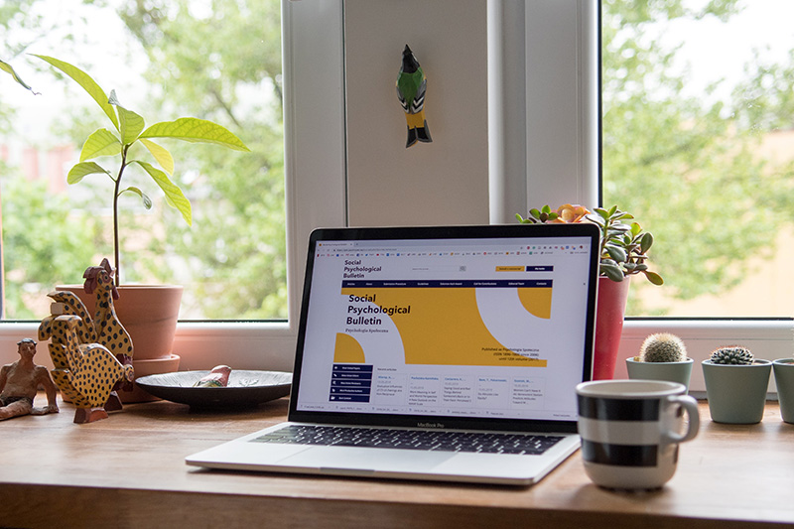

During a session

9. Find the right position
Distance and angle are just as impactful online are they are in face-to-face trauma therapy sessions. Track yourself and the client and take time to explore where you both feel safest and most relaxed. This may change as a session progresses.

10. Protect with your positioning
Consider these for you as therapist:
- Don’t have personal items, such as family photos, visible in the background. Skype has an option to blur your background.
- Have a light in front of your computer to help you be seen clearly.
- Be aware of your on-screen image – have the top of your head as high on the screen as possible and be far enough back to enable your client to see your hands, if necessary.

11. Go extra slow
Because they’re in their own safe space, clients may be less inhibited than when in your practice room – and as a result, may go into processing more quickly. Help contain them by really slowing down.

12. Resource yourself
What do you need to stay grounded, self-contained and open? Some SEPs report having their own favourite cushion to use when working, or having hot water bottles beneath their feet or behind their back. Sensing warmth reminds you you’re not in freeze. Similarly, warming the kidneys helps keep us grounded.
Grounding and centring through a midline and sit-bones pointing downwards can be equally invaluable for preparing for sessions, as well as during sessions, helping to remain attuned and focused on our clients’ needs.

13. Check-in with yourself regularly
Just as you would in a physical session. Check for areas of tension and/or emotion, etc., then, if appropriate, check with the client by self-reporting and asking if what you’re experiencing is yours or theirs.

14. Focus (even more) on legs and feet
More often than not, you won’t see what is happening in your client from the waist down. Thus, encouraging the client to bring regular or frequent attention to their feet and legs helps keep them contained and grounded.

15. Keep boundaries strong
In these times of raised base levels of anxiety, and new (session) locations, we SEPs can help our clients experience safety and autonomy by:
- continually honouring the separate boundaries of ourselves,
- remembering that we meet together, we do not merge, and
- we do not need support from our clients, plus
- taking care not to over-disclose personal information.
We discourage the use of social media with clients for the same reason.

After a session

16. Be gentle with yourself
What helps you mobilise and/or rest? Connect with trusted colleagues and loved ones to resource yourself and help you recharge and flow with the changing tide.

17. Be flexible
As much as it feels OK for you and your code of ethics, it may be helpful in exceptional circumstances, such the coronavirus lockdown, to adapt your communication boundaries by allowing clients to text you when experiencing activation peaks.

